June 18, 2025

Byline: Michelle Williams

[Link](https://www.forbes.com/sites/michellewilliams/2025/06/18/one-sonoma-winemakers-passionate-pursuit-of-expressing-terroir-in-wine/)

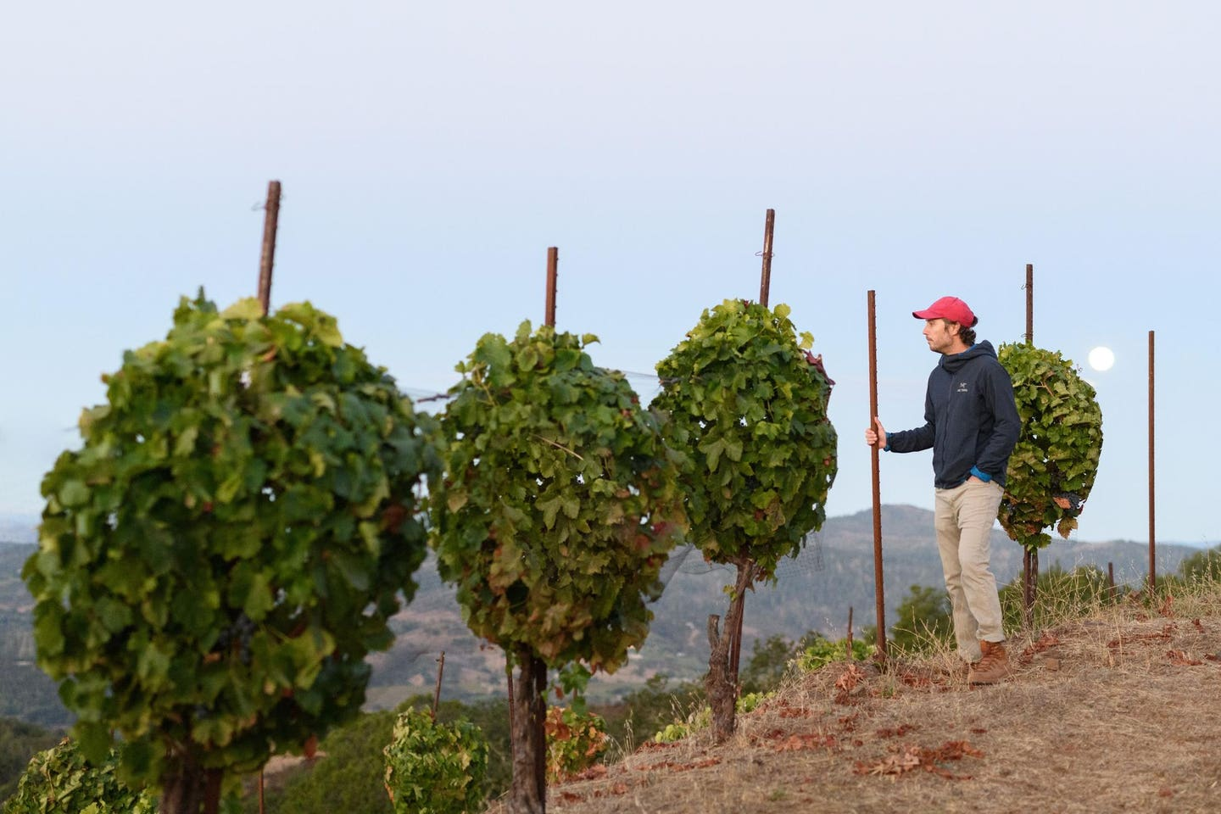

Does Hamel's Nun Canyon Vineyard have the terroir or not?

Walk into a vineyard and what do you see? Vines and soil, sun and sky—a snapshot of place, a moment in the vineyard’s lifetime. The ecosystem here is influenced by a myriad of factors. Some work over eons—building the bedrock, for example—and some change daily. Taken together, along with the wine maker’s hands, these slow and fast factors present a unique taste of time and place in wine.

This concept, known in French as *terroir,* provides what passionate wine enthusiasts believe influence a wine’s character, and the authentic expression of craftsmanship sought by younger wine consumers. Winemakers, by and large, recognize terroir as a key component to wine growing, yet often disagree about how and where it is achieved.

As a Sonoma Valley winemaker, John Hamel, winemaker of [Hamel Family Wines](https://hamelfamilywines.com/), is deeply passionate about expressing Hamel wines’ terroir, something he feels is easier for European winemakers than those in California. To achieve this lofty goal, he partners with world-renowned terroir specialist, [Pedro Parra](https://www.skurnik.com/producer/pedro-parra-y-familia/). The results are a promising work in progress.

**“Does [Hamel Family Wines] have the terroir or not? Because you have all the ideas, all the philosophy, and then you don't have the site. And if you don't have the site, in my experience, there's not many things that you can do.”**

Pedro Parra, World Renowned Terroir Specialist

The Site Makes The Wine

“I love European wines. There’s a character in those wines that you find more often and with more intensity that I would call minerality,” says Hamel. “In California, I think there's a very technologically savvy approach. We're very technical, but the connection between the wines and the place and the resulting minerality that you get in the wines is lower frequency, lower volume.”

In 2016, Hamel learned Parra was asking similar questions about why some regions produce wines of tension and energy with ease while others struggle. Having wrestled with locating unique site expression consulting California wineries in the past, Parra was ready to re-up the challenge. However, he knew it would be risky.

“Does [Hamel Family Wines] have the terroir or not? Because you have all the ideas, all the philosophy, and then you don't have the site. And if you don't have the site, in my experience, there's not many things that you can do,” says Parra.

Hamel Family Wines is located in Sonoma’s Mayacamas Mountains, part of the California Coast Ranges that formed one-hundred million years ago. As the two began researching and mapping the estate vineyards, they discovered basalt in the early stages of decomposition—a bounty of volcanic stones—in the Nuns Canyon vineyard. This high elevation sloped site is filled with fractures formed by a lava flow three million years ago, in a Mediterranean climate. Early signs for expressing terroir.

“The stonier the terroir, the more character, the more depth, more energy, tension, the things that really make a wine distinctive and unique and interesting and fascinating. And it's the thing that I loved about the wines from Europe. Once we were able to dissect the terroir, you can see very clearly the conditions that give you those types of wines,” Hamel says.

Dry-Farming’s Impact On Wine

To maximize this sense of place, Hamel estate has been Demeter certified biodynamic since 2015. Additionally, eighty percent of the vines are not irrigated, a practice known as dry-farming. Because the un-decomposed basalt is fractured rock, the fractures act as a tunnel for rain to flow through while simultaneously allowing the vines’ roots to grow deeper in source of water and nutrients.

Many colleagues told Hamel dry-farming was a bad idea. It is too hard in California and that the quality of the wine would suffer. But an early mentor of Hamel’s, Tod Mostero, director of viticulture and winemaking at [Dominus Estate](https://www.dominusestate.com/)in Napa Valley, demonstrates dry farming can be successful.

Hamel’s experience has been equally successful, finding the vines with deeper root systems produce higher quality wines. He is quick to suggest he is not seeking regenerative farming for the sake of it. Rather, it’s part of the team’s fundamental philosophy of extracting as much expression of place as possible to make the best wines.

He also believes his vines are better adept at weathering climate change perturbations because they are resilient to heat spikes and erratic weather patterns.

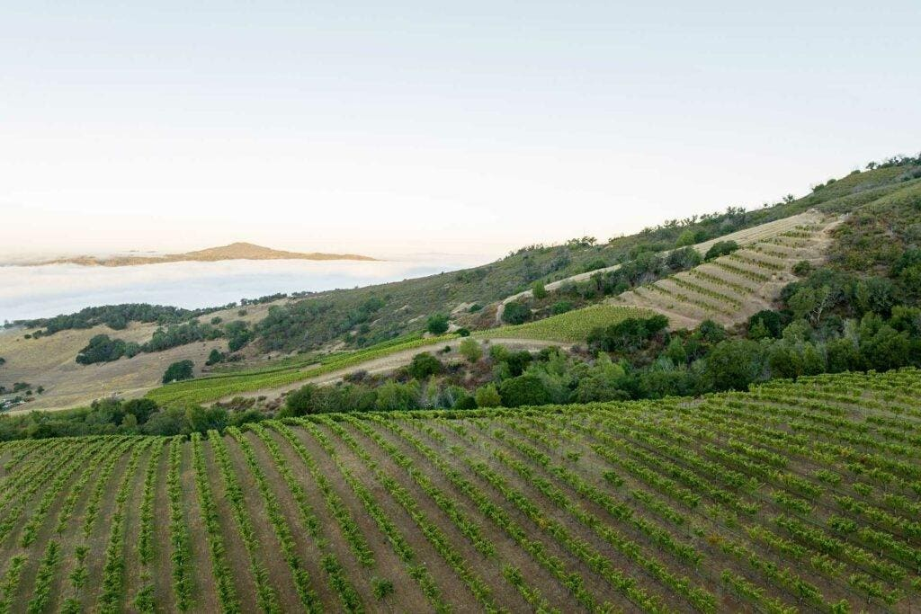

Hamel Family Nuns Canyon Vineyard is a high elevation sloped site is filled with fractures formed by a lava flow three million years ago, in a Mediterranean climate

Let The Site Speak In The Wine

Beyond his vineyard work, Hamel intervenes as little as possible in the winemaking process.

“You see something that's very evocative and, you know, things like oak, things like over maceration, all these tools and equipment in the winery just starts to get in the way of that. And when you show that, you don't want there to be any makeup on that. You want to show the thing itself, Hamel says. “And I think in a way, Pedro cured me of the inherent American mentality, which is if you just work hard enough on something, it'll be good. Terroir is not as democratic as that. Ultimately, we’ve got areas that are very, very good.”

Parra believes over the past nine years they have come a long way in understanding the vineyards and maximizing farming methods to express place through vitality in the glass. What’s next? Parra says its consolidation.

Realizing A Wine Vision

“To me, consolidation is the last stage. And that means that you are confident enough, holistic enough, and you have the confidence to be able to be proud and show it to the rest of the world. You can play the game well, but you need to score. To me, where’re in the beginning of that era.”

However, Parra offers high praise for Hamel. He sees what Hamel is doing is incredible and worthy of respect.

“John is a Ferrari. He’s driving super fast. He has the terroir, the mentality, he’s hungry, and few others are doing this in California. So, the future is incredible. It takes time to get the people to know and respect what is behind the wine, but it’s going to happen. In three years, five, ten, I don’t know. But it’s inevitable because the terroir is great and the wines are great so it’s going to happen.”

Will Hamel Family Wine fully realize John Hamel’s vision? Both men suggest it takes a couple of decades to determine grand cru quality wine. However, the current vintage delivers vibrancy, finesse, and tension, transporting oenophiles and novices alike to the ancient lava flows of Nun’s Canyon Vineyard in the Mayacamas Mountains, truly a sense of place.